Unit 3 - Information Systems
Management Information
P4 - Describe the features and functions of information systems

Introduction
I am going to describe the features and functions of information systems. Furthermore, I am going to name the advantages and disadvantages for each of the branches. Features: data; people; hardware; software; telecommunications. Functions: input; storage; processing; output; control and feedback loops; closed and open systems. MIS stands for Management Information Systems. It says it in the name, it controls the information. This is important for today’s business organisation, because it’s better organised. It combines all the information together in the system and it’s easier to use for the user.

Main part of you assignment:
- Remember you will be discussing about the features you will first attempt to explain the features individually i.e data; people; hardware; software; telecommunications. (Page 88)
- Then you will try to identify some advantages and disadvantages of each of these systems and say which of these features would you like to have in your business and why. (Now we had discussed this in detail when we had and introductory lesson).
- In this part of the assignment you will be discussing about the functions of information systems i.e. input; storage; processing; output; control and feedback loops; closed and open systems (Page 88-89)
- For each of the functions you have described you need to state some possible problems/disadvantages and solutions to these issues.

Features of information system

Data is information that is stored by a computer. This can be any types such as: documents, pictures, videos, programmes and many more. They are two type of data; primary and secondary. Primary is data that is collected first hand. The pros of primary data is that it’s collected original. It is up-to-date so that the data that is collected is unique. For example, if my business done a survey they would go out and ask specific people to complete their questionnaire. However, the big disadvantage is that it’s time-consuming. So, if they spend excessive amount of time completing many questionnaires; they would waste a lot of time focusing on the customers. If they do spend a lot of time, sales would decrease. For secondary data, the advantage of having this data is that it saves huge amount of time. You have the resources online, books, magazines. So, they can just check that, then collecting it by first hand. However, the vital disadvantage is that it may not be up-to-date. For example, if my business wants to check how many people purchase suits and the result is 2012. It would need to be 2013, because the percentage may have fallen.

People are who work for the organisation. They are many advantages and disadvantages of people who can work for your organisation. The advantages are that if you don’t have any employees; the work wouldn’t be complete. So, they complete the work for you. However, the big disadvantage is that they need to complete the work once it’s due. So, they need to be efficient, flexible and versatile. They need to be recruited carefully. Once they have recruited the employee, they can monitor their progress. Another disadvantage is that if a person is ill or on maternity leave, they would need temporary staff. This is the same process as a normal recruitment. However, they would need to do this fast because they would be losing out. I would have people who are committed and dedicated to the job. I wouldn’t have any lazy people. I can monitor their progress and if it’s not up to standard, they can leave.

Hardware is physical components that can be touched. They are more than I am going to name, but here is a few:
- Monitor
- Scanner
- Printer
- Keyboard
- Mouse
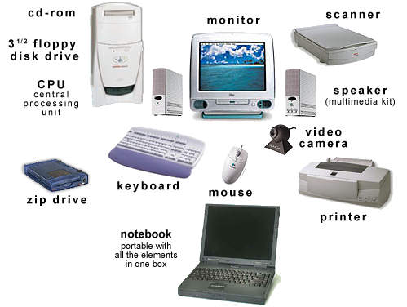
The advantage is that the performance of the hardware is up-to-standard. Furthermore, it keeps all the data safe and secure. However, the disadvantage is it takes time if there is a technical fault in the hardware. For example, if the hard drive or memory is full, they won’t be able to save anything. This is time-consuming, because if they is a technical fault. It would need to be repaired and computer engineers normally take 2-3 weeks to fix it, depending on how big the issue really is. I would have hardware that are rated good and long-term success. So, they can last long even if they cost a lot. I would purchase it.

Software is programmes within the computer. As we all know, technology is updating every year; it’s organisations decision to take into a count either they want the newest update or not. This is important to choose which software they are going to use, because it needs to be important. The disadvantage is that if you decide not to purchase the updated version; some of the Microsoft Office 2013 features are not included in the Microsoft Office 2011. I would choose the most recent as this is much easier to use. Furthermore, it’s expensive because it costs £80-£100 each one. Therefore if the business have 10 computers, it would cost around £1000. The advantage of having anti-virus is that it can be protected from viruses, spams and hacking. They can restrict any sites or access to anything that can distract the employees from work. All softwares are costly. For example, Norton expires every year. So, they would need to renew it. I would, firstly, check if the reviews of this software is good. If it’s worth it and I get recommended this software on many occasions, then I would consider purchasing this software.
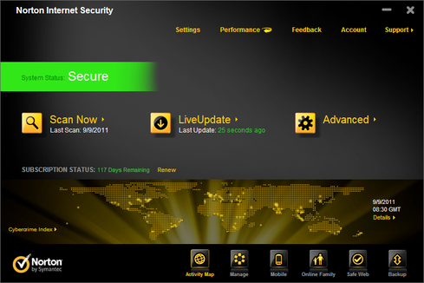
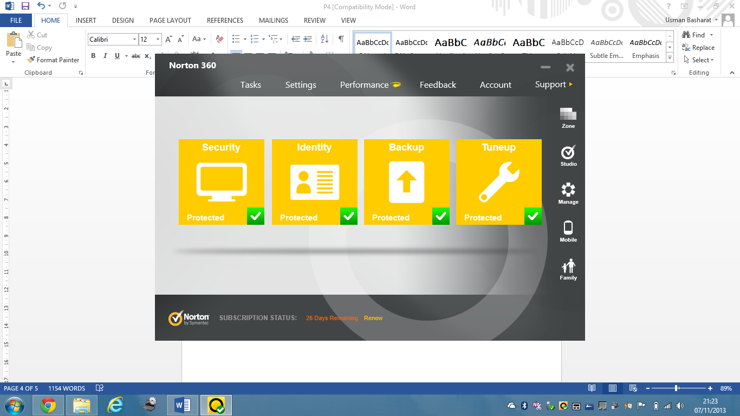

Telecommunications is all about communicating over a distance such as: phone, cable, and broadcasting. The advantages of telecommunication is that it’s quick and accessible information. My employees can contact me if they have any issues and we can deal with the issue easily over the phone. Furthermore, they can speak to more than one person at a time. Therefore, if two people have a problem with each other. They can deal with it easily.

However, the disadvantage is that you cannot exchange any hard copy information. Sometimes, the connection could be poor. So if I and another employee are trying to communicate, the line could be cut. In my business, I would use telecommunication as it’s easier to communicate rather than meeting with the employees as this is time-consuming.
The differences are shown above.

Features of information system

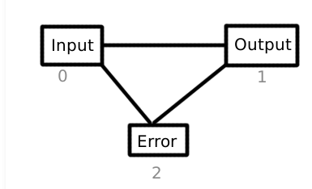
Inputting information into the system, they will always be two parts that occur. The first procedure is checking the information by the employees is safe and correct. The last part of the procedure of the part is they analysis the information. The disadvantage is that if the information has not been correctly checked, the analysis could go wrong. For example, if the information is about the current demand. The demand has been checked variously, but the figures go wrong. This would make the manager make wrong decisions, ending up large amounts of stock. If the information is graphical. It would be more confusing. For example if the number of employees is presented as a pie chart, it would be confusing as how many employees work in different sectors. The possible solution is turn the information from graphical into textual as this would be more presentable and easily to read. This is easily to read as it’s presented visually and clear.

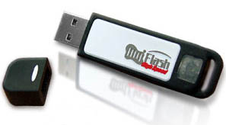
Storage is space allocated for data to be stored. The advantage is that you can access the data and continue the information. For example if you got a meeting or interview, whilst at work, you can save it and continue where the employee left off. Another advantage is that if you got your files backed up, no virus would be able to delete it. It would stay protected. However the disadvantage is that if you don’t backup all your files, then there is a risk of losing all of them. This could be atrocious because, the employee that lost it, they would have to start all over again which is time-consuming. Some of these information should be kept away, externally, for protection reasons and in case of any tragedy that could happen to the information. This could be resolved by getting extending the RAM. So, this would allow more data to be saved.

Processing is simply the data turning into information. At its simplest form, it may involve counting all the money and putting it into the system on Microsoft Excel. Processing data could be on the time of date. They could be two types of processing data. One of them could be presenting information in a week could be less information. The other processing information could be extensive such as, a month or a year. This could be confusing with a lot more figures to deal with. Also, they could miss some vital information. For example, if an employee is inputting all the revenue made and he makes a mistake. However, if he processes the information and makes a mistake. The complex routine could assume the answer and make even more mistakes. The solution to this processing the data could be insert the information carefully and making sure it’s checked by another employee.

Output is how information is presented in terms of data. These have two types, the graphical and textual output. These two outputs could be demonstrated as;
- Charts,
- Diagrams
- Graphs
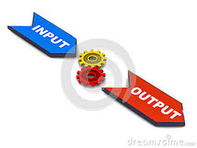
This all could be done on a software, Microsoft Excel. This is presented visually to manage the information. The disadvantage of output is that sometimes the data could be presented difficulty when presenting it to another manager. For example if a manager made a diagram of how the profit is made, it would be difficult for another person to understand if he doesn’t understand it. The solution to this issue could be that they could present both, textual and graphical, output so that others could understand. Some could understand, but they will need to present the information easily to read.
Control and feedback loops- This simply means the feedback that changes its difference according to the output given. For example, it can look at the sales report. Whether the products are doing well or not. It can increase the sales by reducing the price. The disadvantage for this is it can create large amounts of time delay. The potential problem could be valuable time could be lost, completion of work could be delayed. The solution could be is make the process much faster.

Open system and closed system is when two types of information interacts with each other. For example if one employee is in the stock room and another employee sends an order, they will reply back and say the order is coming out. The disadvantage of this is that the employee that is in the stock room may get the order confused. This would result in losing customers. The only solution could be is send a hardcopy to the employee so he doesn’t get confused with the order. Closed system is just sending the information to them, but they cannot receive any data back. This is not appropriate in my business, because they would need to know when the order is ready to collect. The disadvantage is that this is limited output format, but it’s easier to use. Also, you cannot reply back to the employee’s message. So, if he gets confused with the order. He cannot do anything. The only possible solution could be is to switch to open system as this is more appropriate for this organisation.
Conclusion
A management information system (MIS) is information provided that could be organised efficiently and effectively. I think that MIS is very standard and can get answers that you haven’t thought about very quickly. This analysis information that is needed very quickly. It’s easier to use and I would definitely consider using this system.

